**PROJECT REPORT TEMPLATE**

**1 INTRODUCTION**

* 1. Overview

A CRM is a system that helps schools to manage the entire lifecycle of a potential customer – sometimes also referred to as a lead. With a CRM, you can track and store data that’s important to your operations, all in one easy-to-access place.

1.2 Purpose

* CRM is a strategy that companies used to manage interactions with customers and potential customers.
* The CRM system has helps us to focus on the right recruitment activities and the structure the communications with other prospective and admitted students.
* This technology helps school manage their relationships with students and parents, and it can be a powerful tool for increasing admissions.

1. **PROBLEM DEFINITION AND DESIGN THINKING**
   1. Empathy Map

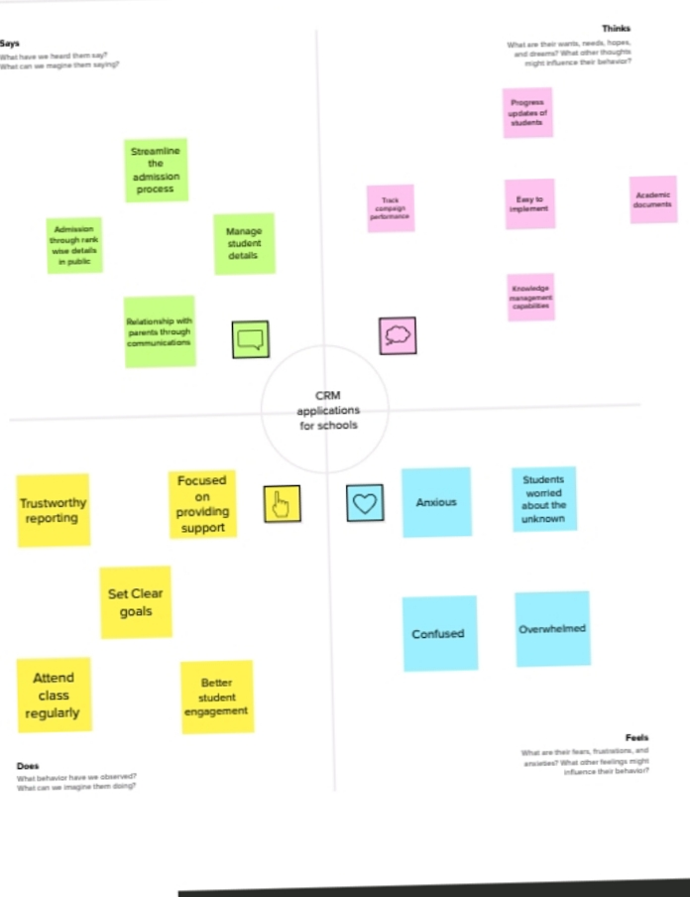

* 1. Ideation and Brainstorming Map

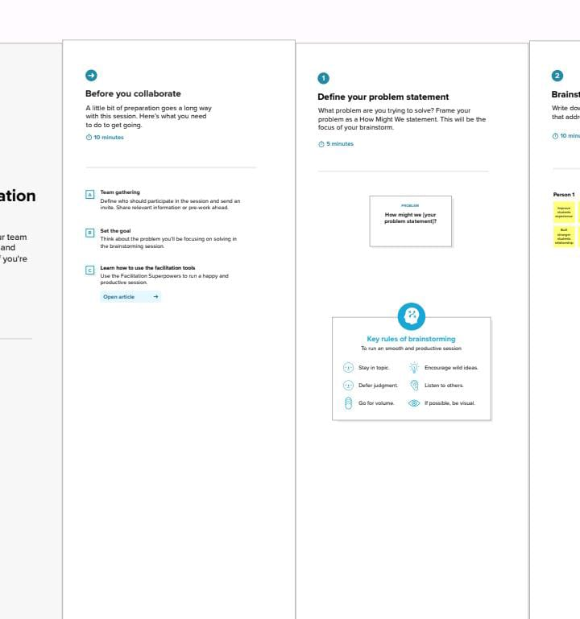

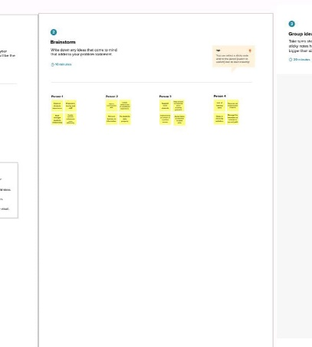

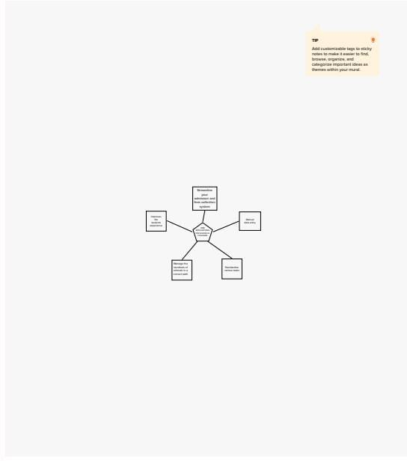

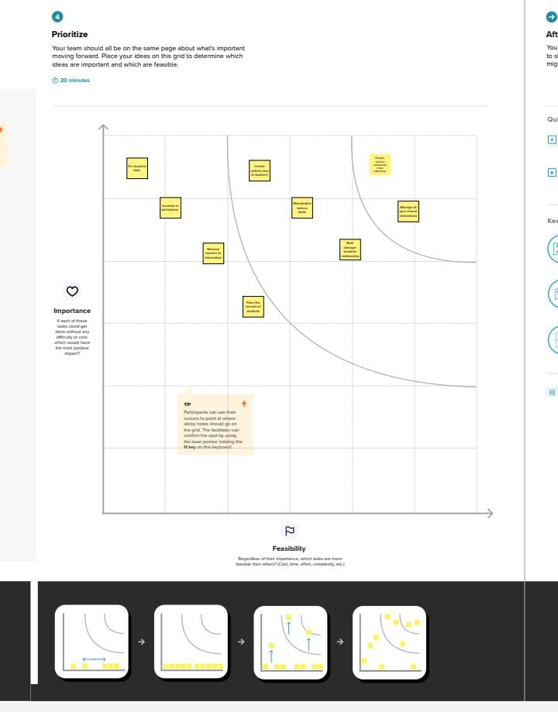

1. **RESULT**
   1. Data Model

|  |  |
| --- | --- |
| Object Name | Fields in the object |
| School | |  |  | | --- | --- | | Field Label | Data Type | | District | Text Area | | State | Text Area | | School | Text Area | |
| Student | |  |  | | --- | --- | | Field Label | Data Type | | Phone Number | Phone | | Result | Picklist | | Class | Number | | Marks | Number | |
| Parent | |  |  | | --- | --- | | Field Label | Data Type | | Parent Address | Text Area | | Parent Number | Phone | |

* 1. Activity and Screenshot

Creation of objects for School Management:

Firstly create school object

1. Go to set up, click object manager.
2. Then click create
3. Select custom object

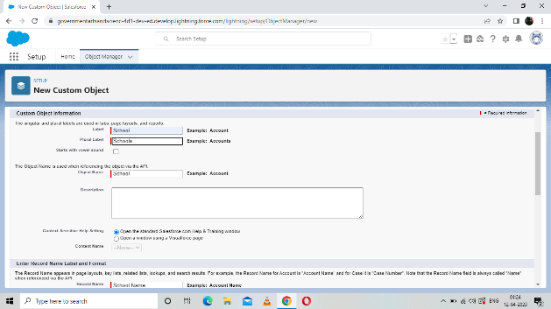

Click save

Similarly create student and parent object

Creation of App Manager:

Create school management app

Creation of custom field:

Creation of field for the school object:

1. Go to set up and click object manager
2. Select school
3. Select field and relationship and click new
4. Select data type as text area

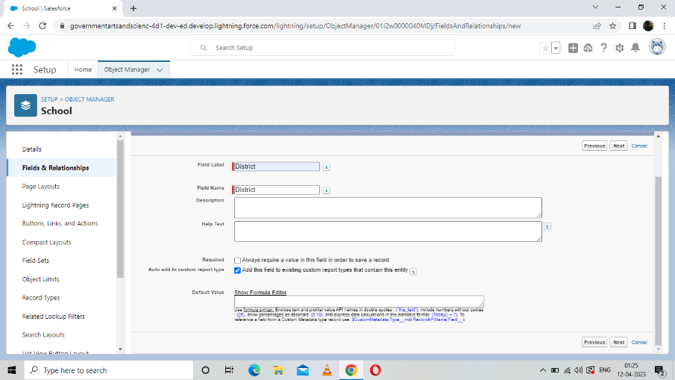

Similarly create state and school field labels

Follow the above procedures and create fields for the student and parent object

Let’s create Profiles, User and Permissions sets.

1. Go to School Management app
2. ENTER all data

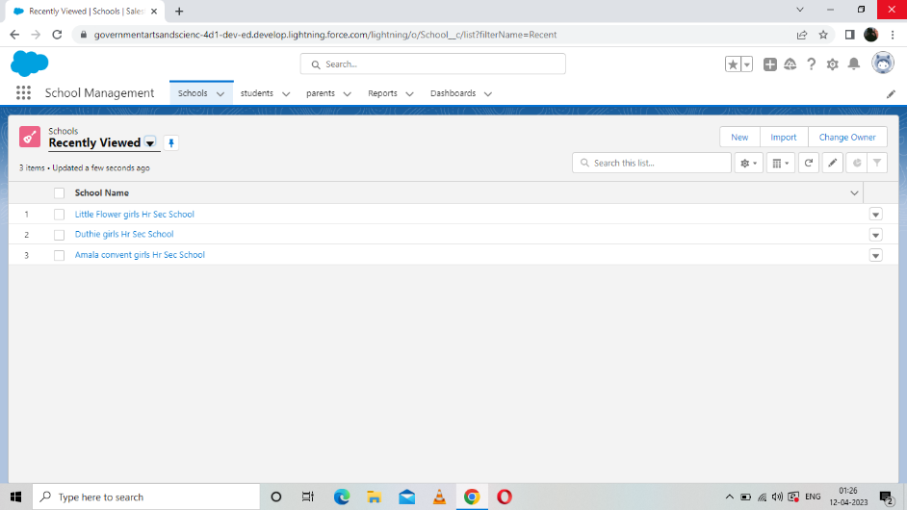

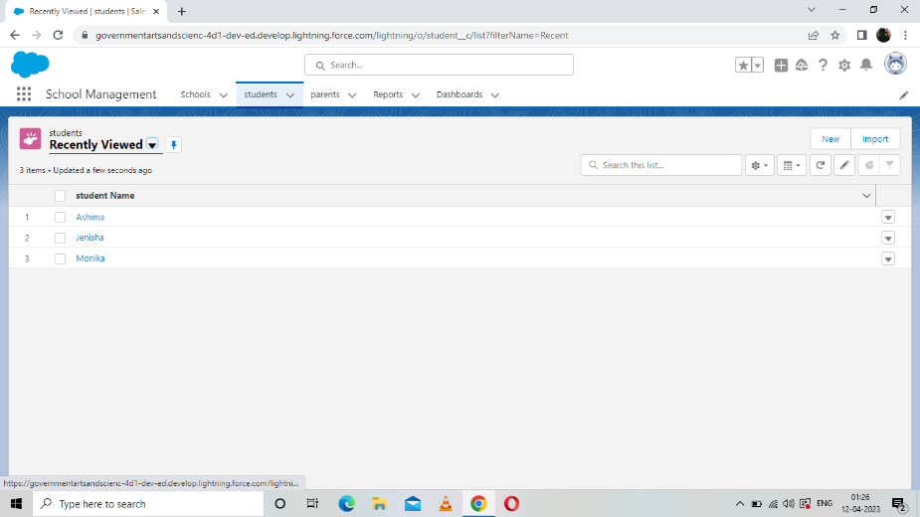

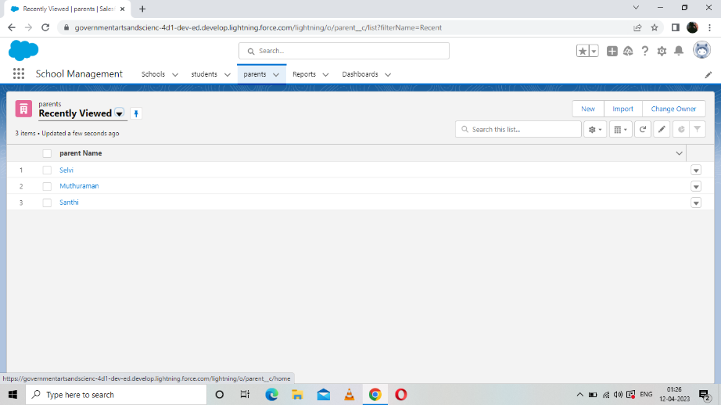

* After entering the data, create new report
* Select the report type and start report

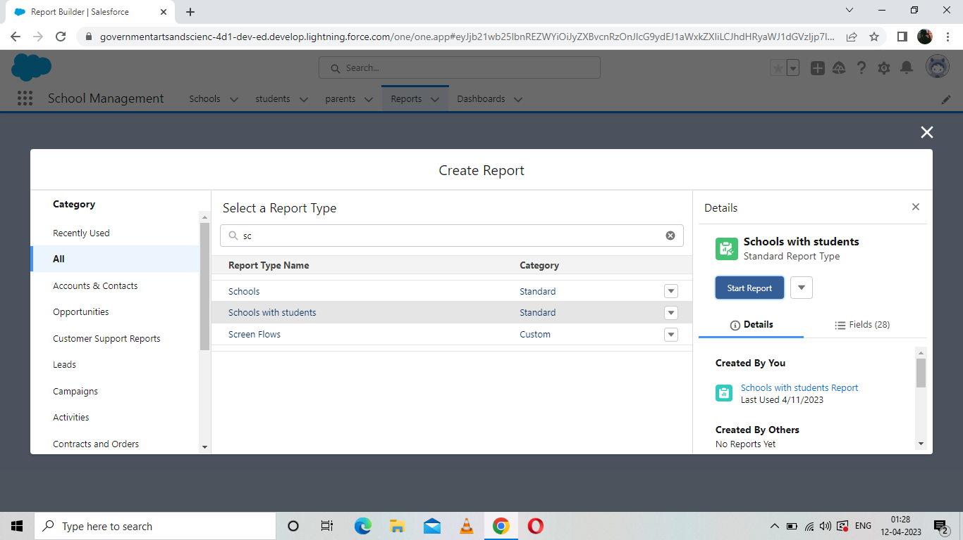

* Save and run

1. **TRAILHEAD PROFILE PUBLIC URL**

Team Lead: <https://trailblazer.me/id/acze12xxxuesty>

Team Member 1: <https://trailblazer.me/id/neetm5>

Team Member 2: <https://trailblazer.me/id/meerm4>

Team Member3: <https://trailblazer.me/id/megha13>

1. **ADVANTAGES AND DISADVANTAGES**

**Advantages:**

* Reduction in the cost of expenses
* Improving the quality of service/product
* Improving the organization management process
* Increased customer loyalty
* History of work with each student

**Disadvantages:**

* Software subscriptions or purchase fees
* Customization
* Premium upgrades or reporting features
* IT resources needed
* Handware or software requirements
* Staff training and upskilling

1. **APPLICATIONS**

* Tracking customers
* Collecting data for marketing
* Improving interactions and communications
* Streamlining internal sales processes
* Planning your operations

1. **CONCLUSION**

Unlike many other corporate guidelines, CRM focuses on the customer and customer relationships rather than on sales or profits. This approach is particularly widespread in the business-to-business area where it is often very difficult for companies to attract new customers. Although online marketing made things much easier and opened up new solutions, business-to-business still remains a sector where it is difficult, and above all expensive, for any company to acquire fresh customers.

To make a CRM systems easer to work with, most software products include additional features such as the integration of office program, email clients, task management applications and time management tools, plus the ability to import and export data.

Findings:

The development and the implementation of a CRM project in an state community school was examined as were the benefits realized by implementing CRM. As schools and colleges increasingly embrace distance learning and e-business, CRM will become stronger and more pervasive. Semi structured interviews were conducted with individuals involved with the planning, development advantage and implementation of a state wide CIS system.

Viewing students as customers provides a competitive advantage and enhances a colleges ability to attract, retain and serve its customers. As colleges increasingly embrace distance learning and e-business, CRM will become more pervasive.

1. **FUTURE SCOPE**

* Bright and prominent
* Leading experts are continuously working to evolve the features of this platform.
* Salesforce CRM will maintain its lead in the future and will develop better customer-centric insights and experiences.